**EXPERIMENT 4**

**Design entity relationship diagram (ERD) for the Railway Reservation System**

**Entity-Relationship Diagram (ERD) for Railway Reservation System**

An **Entity-Relationship Diagram (ERD)** is a visual representation of the database structure, showing the relationships between different entities in a system. Below is a **detailed ERD for a Railway Reservation System**:

**Entities and Their Attributes**

1. **User** (Passenger)
   * User_ID (Primary Key)
   * Name
   * Email
   * Phone Number
   * Address
   * Gender
   * Age
2. **Admin**
   * Admin_ID (Primary Key)
   * Name
   * Email
   * Phone Number
3. **Train**
   * Train_ID (Primary Key)
   * Train_Name
   * Train_Type (Express, Local, etc.)
   * Source_Station
   * Destination_Station
   * Departure_Time
   * Arrival_Time
4. **Station**
   * Station_ID (Primary Key)
   * Station_Name
   * Location
5. **Schedule**
   * Schedule_ID (Primary Key)
   * Train_ID (Foreign Key from Train)
   * Station_ID (Foreign Key from Station)
   * Arrival_Time
   * Departure_Time
   * Date
6. **Ticket**
   * Ticket_ID (Primary Key)
   * User_ID (Foreign Key from User)
   * Train_ID (Foreign Key from Train)
   * Journey_Date
   * Seat_Number
   * Class_Type (Sleeper, AC, General, etc.)
   * Price
   * Booking_Status (Confirmed, Waiting, Canceled)
   * Payment_ID (Foreign Key from Payment)
7. **Payment**
   * Payment_ID (Primary Key)
   * User_ID (Foreign Key from User)
   * Ticket_ID (Foreign Key from Ticket)
   * Payment_Mode (Credit Card, Debit Card, UPI, etc.)
   * Amount
   * Payment_Status (Successful, Failed, Pending)
8. **Seat**
   * Seat_ID (Primary Key)
   * Train_ID (Foreign Key from Train)
   * Seat_Number
   * Class_Type
   * Availability_Status (Available, Booked)
9. **Booking**
   * Booking_ID (Primary Key)
   * User_ID (Foreign Key from User)
   * Ticket_ID (Foreign Key from Ticket)
   * Booking_Date
   * Booking_Status (Confirmed, Pending, Canceled)
10. **Cancellation**
    * Cancellation_ID (Primary Key)
    * Ticket_ID (Foreign Key from Ticket)
    * Cancellation_Date
    * Refund_Amount

**Relationships**

1. **User can book multiple Tickets** → (One-to-Many between User and Ticket)
2. **A Train stops at multiple Stations** → (One-to-Many between Train and Station via Schedule)
3. **A Train has multiple Seats** → (One-to-Many between Train and Seat)
4. **Each Ticket is linked to a Train** → (Many-to-One between Ticket and Train)
5. **Each Ticket is linked to a Payment** → (One-to-One between Ticket and Payment)
6. **A User can make multiple Payments** → (One-to-Many between User and Payment)
7. **A Ticket can be canceled** → (One-to-One between Ticket and Cancellation)
8. **An Admin manages Train details** → (One-to-Many between Admin and Train)

**ERD Diagram Representation (Description)**

* **Entities**: Represented as rectangles.
* **Attributes**: Represented as ovals connected to entities.
* **Primary Keys**: Underlined in attributes.
* **Relationships**: Represented as diamonds between entities with appropriate cardinalities (1:1, 1:M, M:N).

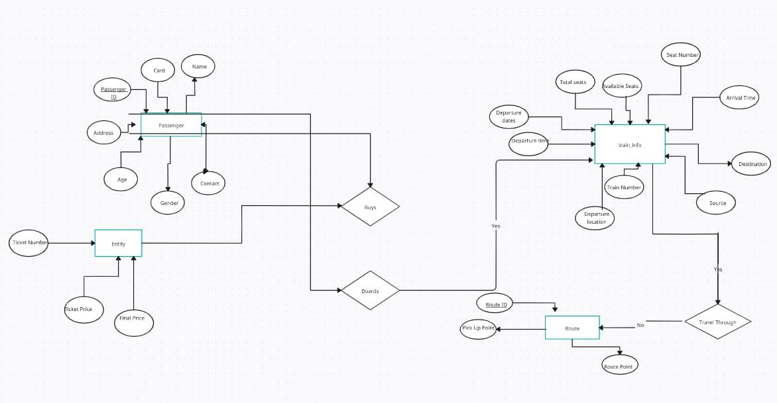

**Entity relationship diagram (ERD) for the Railway Reservation System**